

OpenEVSE – Developers Guide

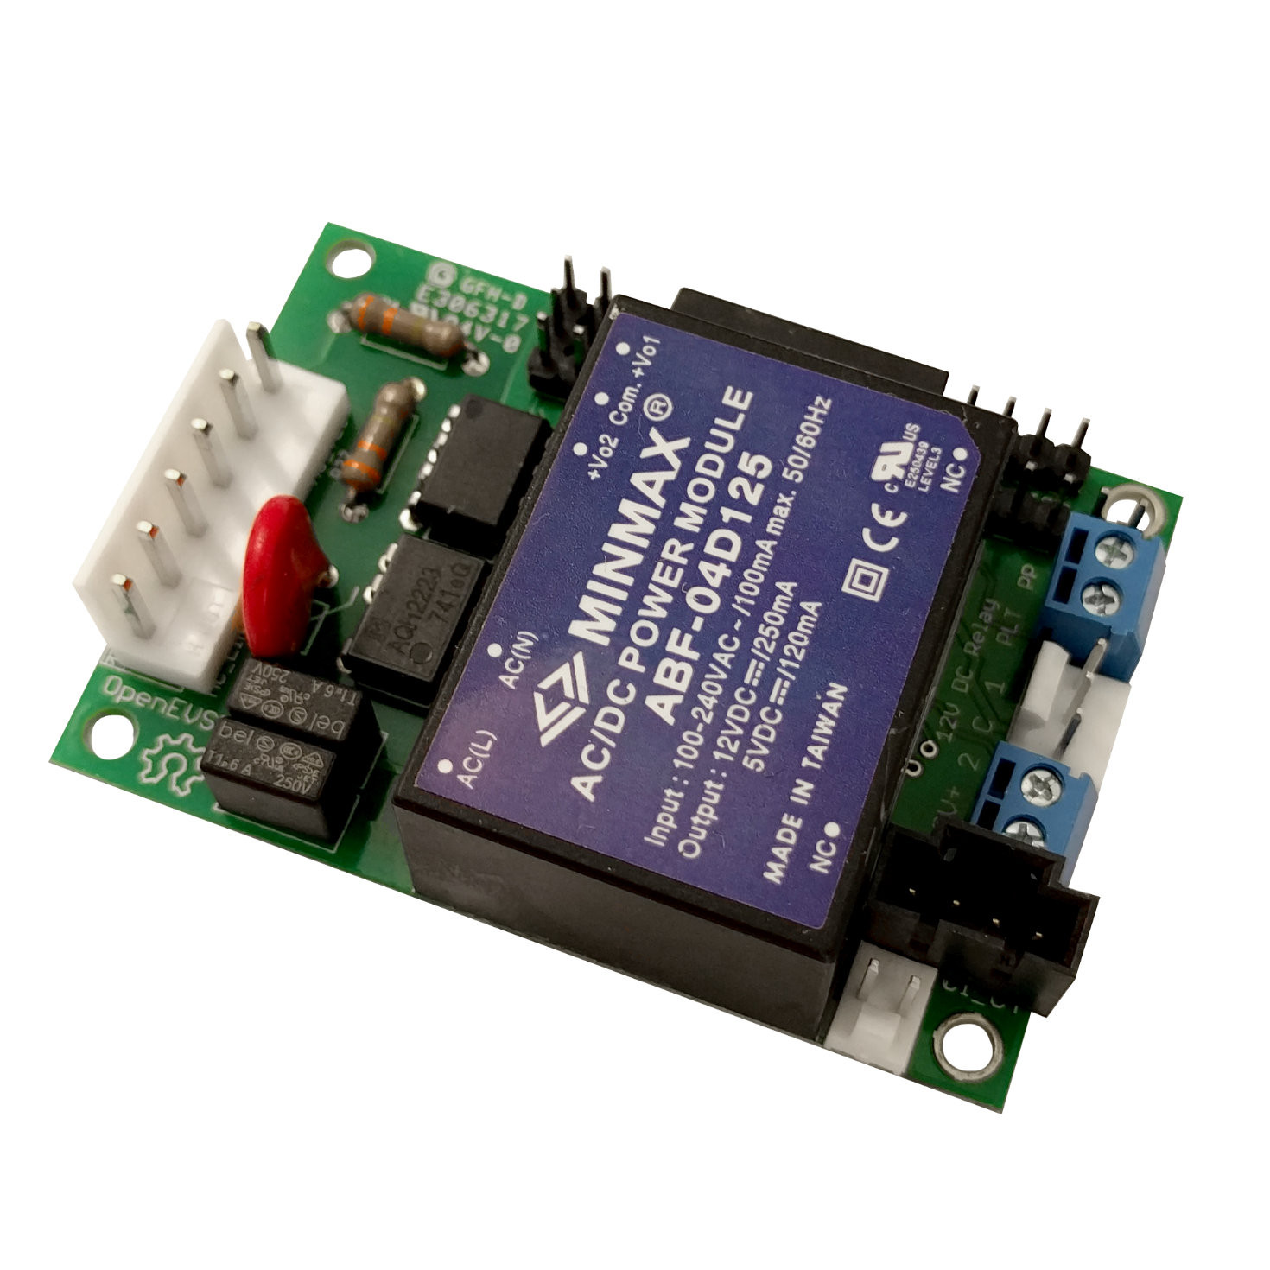   
**MQTT**

http://www.openevse.com [](mailto:info@openevse.com?subject=OpenEVSE%20Info) [](http://www.twitter.com/openevse/) [](http://www.pinterest.com/openevse/) [](https://www.github.com/openevse/) [](http://www.facebook.com/openevse/)



**Read and save these instructions prior to installing and operating your Charging Station. Retain this installation guide for maintenance and troubleshooting information. If you have further questions, contact Customer Service at support@openevse.com.**

**WARNING:** To reduce the risk of fire, electric shock, and serious bodily injury, observe the following:

• Installation work and electrical wiring must be done by qualified person(s) in accordance with all applicable codes and standards.

• When cutting or drilling into structure, do not damage electrical wiring and other hidden utilities.

• Use this device only in the manner intended.

**CAUTION:** The installation of this charging Station must be in accordance with all national and local electrical codes.

**CAUTION:** Exercise caution and common sense when powering the device. Do not connect to a damaged power source.

**WARNING:** Power must be disconnected before installation and servicing, cleaning, and other user-maintenance. Failure to disconnect power creates risk of fire, electric shock, and serious bodily injury.

**CAUTION:** The product warranty will not cover equipment damage or failure that is caused by improper installation or operation.

**WARNING:** Do not install in an environment that is excessively dusty, conductive, corrosive, or gas-filled, is exposed to open flames (e.g., gas-burning stoves), is near strong chemicals or solvents, or where there is excessive heat, shock, or vibration.

**CAUTION:** This charging station is not intended for use by persons (including children) with reduced physical, sensory, or mental capabilities, or lack of experience and knowledge, unless they have been given supervision or instruction concerning the use of the charging station by a person responsible for their safety. Children should be supervised to ensure that they do not play with the charging station.

Contents

License 3

MQTT 4

Prerequisites 4

MQTT Setup 4

MQTT Publish 5

MQTT Subscribe 6

Advanced RAPI over MQTT 7

OpenEVSE Remote API 7

Station Commands 9

Set Commands 10

Get Commands 12

RAPI over WiFi 14

Additional Resources 15

# 

# License

This manual was written by OpenEVSE LLC and is released under the Creative Commons 3.0 with Attribution, share alike license.

OpenEVSE is a open project with source materials freely shared. OpenEVSE may be used for commercial purposes in accordance with the following licenses:

OpenEVSE Code license – **GNU General Public License v3**  
<http://www.gnu.org>

 [GPLv3 Logo] 

OpenEVSE Content license (including this document) – **Creative Commons 3.0 with Attribution Share alike (CC 3.0 BY-SA)**  
<http://creativecommons.org/licenses/by-sa/3.0/>



The OpenEVSE Project and Source code has been evaluated by the Open Source Hardware Foundation and meets the requirements for Open Hardware. The registration number for OpenEVSE is US000028.

# 

# MQTT

## Prerequisites

* OpenEVSE controller with firmware 4.8.0 or higher
* OpenEVSE WiFi with firmware 3.7.4 or higher
* Connected to an Access Point with network access
* MQTT Broker on the network

## MQTT Setup

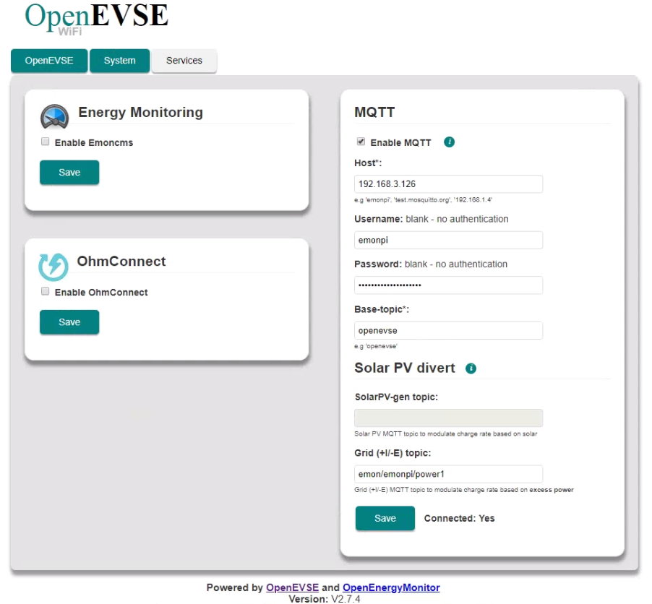

* Using a web browser enter the IP address of your OpenEVSE WiFi
* Click the Services tab
* Click the “Enable MQTT” Checkbox
* Enter the IP Address or hostname for the MQTT Broker
* Enter the Username and Password for the MQTT Broker
* Enter the <base-topic> OpenEVSE will publish. **Default** openevse

## MQTT Publish

Once connected to a MQTT Broker, OpenEVSE will publish the many commonly used values at regular intervals.

Structure - <base-topic>/<sub-topic> <value>  
Default - <base-topic> openevse

Published - <sub-topic>  
Published to broker every 30 seconds

openevse/amp Measured current in milliamps  
openevse/wh Calculated watthours for the current session   
openevse/temp1 Sensor value in 10th degree C (if installed)  
openevse/temp2 Sensor value in 10th degree C (if installed)  
openevse/temp3 Sensor value in 10th degree C (if installed)  
openevse/pilot Pilot current sent to vehicle in Amps (6-80)  
openevse/state EVSE State 1–Ready, 2-Connected, 3-Charging, 4-Error  
openevse/freeram WiFi free Ram  
openevse/divertmode Divert Mode 1–Normal, 2–Eco Divert

Published to broker every 5 seconds

openevse/chargerate Calculated power available from Grid I/E Topic   
openevse/grid_ie Last Value received on Grid I/E Topic   
openevse/divert_update Time since received on Grid I/E Topic

## MQTT Subscribe

**Grid I/E Topic:**

<topic>/<subtopic> defined in OpenEVSE WiFi interface. Example emon\emonpi\power1

OpenEVSE will subscribe to an energy topic and adjust charging power based an available energy. Available energy must be represented in negative watts. Example: A residence is producing 1077 watts of excess energy from a solar system, the solar/energy monitoring system should publish -1077 to MQTT on the topic OpenEVSE was set to subscribe.

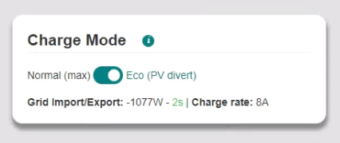

**Divert Mode:**

Divert mode can be enabled or disabled over MQTT, OpenEVSE subscribes to the <base-topic>/divertmode/set.

<base-topic>/divertmode/set Divert Mode 1–Normal, 2–Eco Divert

# Advanced RAPI over MQTT

OpenEVSE subscribes to a <base-topic>/rapi/in topic and will execute commands, check status and change settings. Commands received over MQTT are sent to the OpenEVSE controller via serial using the OpenEVSE Remote API (RAPI). Responses from the OpenEVSE controller are published to <base-topic>/rapi/out/.

Commands - <base-topic>/rapi/in/<command>  
Response - <base-topic>/rapi/out/<response>

## OpenEVSE Remote API

OpenEVSE Remote API (RAPI) is a simple lightweight communications protocol. RAPI allows the user/application to:

* Execute Commands
* Get Status
* Change Settings
* Debug

RAPI is designed to work in any communications environment including high loss connections such as wireless. RAPI provides optional features to ensure reliable communications:

* Command/Response
* Checksum (NONE, SUM, XOR [recommended])
* Sequence ID

**RAPI documentation is located in the OpenEVSE Source Code, file rapi_proc.h on Github**[**Link**](https://github.com/OpenEVSE/open_evse/blob/stable/firmware/open_evse/src/rapi_proc.h)**.**

**XOR checksum (recommended)**

**$cc pp^xk\r**

**No checksum (FOR Experimentation ONLY)**

**$cc pp\r**

**Checksum + Sequence ID**

**$cc pp :ss^xk\r**

**Structure**

**$= start of RAPI command  
cc = 2-letter command  
pp = parameters  
xk = 2-hex-digit checksum - 8-bit XOR of all characters before '^'  
ss = optional 2-hex-digit sequence id - response will echo the sequence id - ss CANNOT be 00, which is reserved as an invalid value  
\r = carriage return = 13d = 0x0D**

**Response format**

**$OK [optional parameters] [:ss]^xk\r – success  
$NK [optional parameters] [:ss]^xk\r – failure  
Checksum and Sequence ID are only present if send with the command**

**Asynchronous notification messages**

**$ST state\r - EVSE state transition - sent whenever EVSE state changes state: EVSE_STATE_xxx**

**$WF mode\r - Request client WiFi mode:  
WIFI_MODE_XXX**

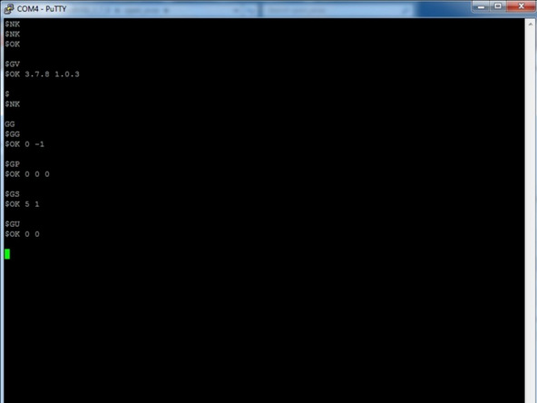

## ****Station Commands****

**Station commands can control the availability of the charging station or change the properties of the station such as LCD color or text.**

**Enable/Disable/Sleep**

**FS puts the charging station in a “not ready” normal state (pilot high PWM off)  
FD disables the station in a “not ready” error state (pilot low PWM off)  
FE enables the station in a “ready” state (pilot high PWM on if connected)**

**Text on LCD**

**F0 0 Disable display updates to give RAPI control of display  
FP Write desired message to LCD  
F0 1 Enable display updates to give OpenEVSE controller control of display**

|  |  |  |  |  |
| --- | --- | --- | --- | --- |
| **Command** | **Parameter** | **RAPI + XOR** | **Response** | **Description** |
| F0 | 0 | $F0 0^42 | $OK^20 | Disable display updates |
|  | 1 | $F0 1^43 | $OK^20 | Enable display updates |
| F1 |  | $F1^53 | $OK^20 | simulate button press |
| FB | 0 | $FB 0^30 | $OK^20 | LCD Backlight OFF |
|  | 1 | $FB 1^31 | $OK^20 | LCD Backlight RED |
|  | 2 | $FB 2^32 | $OK^20 | LCD Backlight GREEN |
|  | 3 | $FB 3^33 | $OK^20 | LCD Backlight YELLOW |
|  | 4 | $FB 4^34 | $OK^20 | LCD Backlight BLUE |
|  | 5 | $FB 5^35 | $OK^20 | LCD Backlight VIOLET |
|  | 6 | $FB 6^36 | $OK^20 | LCD Backlight TEAL |
|  | 7 | $FB 7^37 | $OK^20 | LCD Backlight WHITE |
| FD |  | $FD^26 | $OK^20 | Disable EVSE |
| FE |  | $FE^27 | $OK^20 | Enable EVSE |
| FP | text | $FP 0 0 Hello World^32 | $OK^20 | Print Text to LCD |
| FR |  | $FR^30 | $OK^20 | Reset EVSE |
| FS |  | $FS^31 | $OK^20 | Sleep EVSE |

## ****Set Commands****

**Set commands change common firmware and behavior options such as setting the station timers, Service Level and charge current.**

**Maximum Current**

**SC sets the stations maximum charge current and adjusts the pilot signal duty cycle advertised to the vehicle. This setting can be adjusted dynamically as desired, the vehicle must comply.**

**The default action is to save new current capacity to EEPROM. If frequent changes are expected, a V flag should be appended to the command to prevent the changed from being saved to EEPROM.**

**Minimum and Maximum charge currents can compiled into firmware, for enhanced security these cannot be modified over RAPI. Modification requires re-flashing firmware via an Inline Serial Programmer (ISP). If the commanded setting is outside the defined range RAPI will return $NK and the current setting.**

**If OpenEVSE is currently experiencing an over temperature event, raising current capacity will fail and return $NK and the current setting.**

**Service Level**

**SL sets the Service level on the display and uses the current set in EEPROM. This should be set based on the capabilities of the station and the input service.**

**For countries with single phase 220-240v power Service level should be set to L2.**

**In the United states or other countries with split phase power 120 or 240v the service level can be set to auto. OpenEVSE will detect power on each line and determine if the power is 120v or 240v.**

**Timers**

**ST will set standard Start (hour and minute) and Stop (hour and minute) timers. OpenEVSE will sleep outside of the set time. Sleep can be overridden by pressing the button or sending the F1 command to simulate a button press. Once the Start time has occurred the station will wake and begin charging if a vehicle is attached.**

**Session Limits**

**Limits can be defined for the current charging session based on time (charge for 2hours and 30 minutes) or energy added in kWh (add only 10kwh). S3 sets a time limit in 15 minute increments. S3 10 would set the station to charge for 150 minutes (2 hours and 30 minutes). SH sets the kwh limit. SH 10 will add a maximum of 10kwh to the vehicle.**

|  |  |  |  |  |
| --- | --- | --- | --- | --- |
|  | **Parameter** | **Parameter** | **RAPI + XOR** | **Description** |
| S0 |  | 0 | $S0 0^57 | Set Display type Monochrome |
|  |  | 1 | $S0 1^56 | Set Display type Color |
| S1 |  | yr mo dy hr mn sc | $S1 18 10 18 12 30 00 | Set RTC clock 2018 Oct 18 12:30:00 |
| S2 |  | 0 | $S2 0^55 | Read Ammeter only while charging |
|  |  | 1 | $S2 1^54 | Read Ammeter in all states |
| S3 |  | 0 - 255 | $S3 4^50 | Session Limit x * 15 minutes |
| S4 |  | 0 | $S4 0^53 | Socket Unlock (IF enabled and Installed) |
|  |  | 1 | $S4 1^52 | Socket Lock (IF enabled and Installed) |
| SA | scale | offset | $SA 182 0^3D | Current Measurement Calibration |
| SC | amps |  | $SC 24^12 | Set Current and Save to EEPROM |
|  |  | V | $SC 24 V^64 | Set current and DO NOT Save to EEPROM |
| SH |  | kwh | $SH 10^1E | Session Limit kwh (Ex stop after 10kwh) |
| SK |  | 0 | $SK 0^2C | Set Station kwh Total to 0 |
| SL |  | 1 | $SL 1^2A | Service Level 1 |
|  |  | 2 | $SL 2^29 | Service Level 2 |
|  |  | A | $SL A^5A | Autodetect Service level - US split phase |
| ST | starthr mn | endhr mn | $ST 0 0 0 0^23 | Set Start and End Timers |

## ****Get Commands****

**Get commands retrieve status the current state, settings and values of sensors.**

**Power and Energy**

**GG will get the current measured power output in milliamps. GU will get the Usage statistics for the current session and total as calculated by the OpenEVSE controller.**

**Temperature**

**GP will get the temperatures from any installed temperature sensor is 10th of a degree C. Most OpenEVSE Stations have just 1 sensor installed.**

|  |  |  |  |
| --- | --- | --- | --- |
|  | **RAPI + ck** | **Response** | **Description** |
| G0 | $G0^53 | $OK 0^30 | Get EV connected State - Disconnected |
|  |  | $OK 1^31 | Get EV connected State - Connected |
|  |  | $OK 2^32 | Get EV connected State - Unknown |
| G3 | $G3^50 | $OK count | Get Session time limit count * 15 minutes |
| G4 |  | $OK 0^30 | Get Lock Status - Unlocked |
|  |  | $OK 1^30 | Get Lock Status - Locked |
| GA | $GA^22 | $OK scale offset | Get Ammeter Calibration Settings |
| GC | $GC^20 | $OK minamp maxamp | Get controllers Min and Max Current |
| GD | $GD^27 | $OK starthr min endhr mn | Get Charge Timer Start and End time |
| GE | $GE^26 | $OK amp flags(hex) | Get Current and settings |
| GF | $GF^25 | $OK gfi nognd stkrly | Get Fault Counters GFI Ground and Stuck Relay |
| GG | $GG^24 | $OK milliamps -1 | Get measured current in milliamps |
| GH | $GH^2B | $OK kwh | Get Session charge limit in kwh |
| GO | $GO^2C | $OK ambient ir | Get Overtemperature threshold 10th °C |
| GP | $GP^33 | $OK ds3231 mpc9808 tmp7 | Get Temperature from sensors -2560 = not installed |
| GS | $GS^30 | $OK state elapsed | Get EVSE State and elapsed charge time |
| GT | $GT^37 | $OK yr mo dy hr mn sc | Get Time Year Month Day Hour Minute Second |
| GU | $GU^36 | $OK wattsec wtotal | Get Energy session watt seconds and total kwh |
| GV | $GV^35 | $OK firmware protocol | Get EVSE firmware and protocol version |

**Debugging**

|  |  |  |  |  |  |
| --- | --- | --- | --- | --- | --- |
|  | **Feature** | **Parameter** | **RAPI + XOR** | **Response** | **Description** |
| FF | D | 0 | $FF D 0^50 | $OK^20 | Feature Diode Check Disable |
|  | D | 1 | $FF D 1^51 | $OK^20 | Feature Diode Check Enable |
|  | E | 0 | $FF E 0^51 | $OK^20 | Feature Command Echo Disable |
|  | E | 1 | $FF E 1^50 | $OK^20 | Feature Command Echo Enable |
|  | F | 0 | $FF F 0^52 | $OK^20 | Feature GFI Self Test Disable |
|  | F | 1 | $FF F 1^53 | $OK^20 | Feature GFI Self Test Enable |
|  | G | 0 | $FF G 0^53 | $OK^20 | Feature GMI Disable |
|  | G | 1 | $FF G 1^52 | $OK^20 | Feature GMI Enable |
|  | R | 0 | $FF R 0^46 | $OK^20 | Feature Stuck Relay Test Disable |
|  | R | 1 | $FF R 1^47 | $OK^20 | Feature Stuck Relay Test Enable |
|  | T | 0 | $FF T 0^40 | $OK^20 | Feature Temperature Monitoring Disable |
|  | T | 1 | $FF T 1^41 | $OK^20 | Feature Temperature Monitoring Enable |
|  | V | 0 | $FF V 0^42 | $OK^20 | Feature Vent Required Check Disable |
|  | V | 1 | $FF V 1^43 | $OK^20 | FeatureVent Required Check Enable |
| T0 |  | amp | $T0 75 | $OK | Set Fake Charging Current |
| Z0 |  | delay hold |  |  | Relay delay and hold PWM duty cycle |

**Z0 FOR TESTING RELAY_AUTO_PWM_PIN ONLY**

**Z0 closems holdpwm  
 closems(dec) = # ms to apply DC to relay pin  
 holdpwm(dec) = pwm duty cycle for relay hold 0-255**

|  |  |
| --- | --- |
|  |  |

# RAPI over WiFi

The OpenEVSE WiFi interface provides a great place to test RAPI commands. To enable RAPI over WiFi:

* Click the System Tab
* Click the Developers Mode switch
* Click the RAPI tab
* Enter Desired command and click Send

[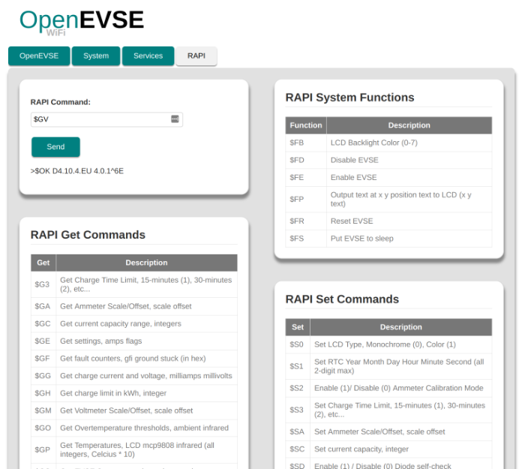](https://github.com/OpenEVSE/ESP8266_WiFi_v2.x/blob/stable/docs/rapi-web.png)

# Additional Resources

Online Solutions, Forums and Trouble Tickets   
<http://support.openevse.com>  
E-mail [support@openevse.com](mailto:support@openevse.com)

Online Guides  
<http://guides.openevse.com>

Store  
<http://store.openevse.com>

Website  
<http://www.openevse.com>

Source Code - Firmware - Schematics, etc.  
<https://github.com/openevse>